J.K.K.MUNIRAJAH COLLEGE OF
AGRICULTURAL SCIENCE
(Affiliated to Tamil Nadu Agricultural University)
T.N.Palayam – 638 506, Gobi (Tk), Erode (Dt).
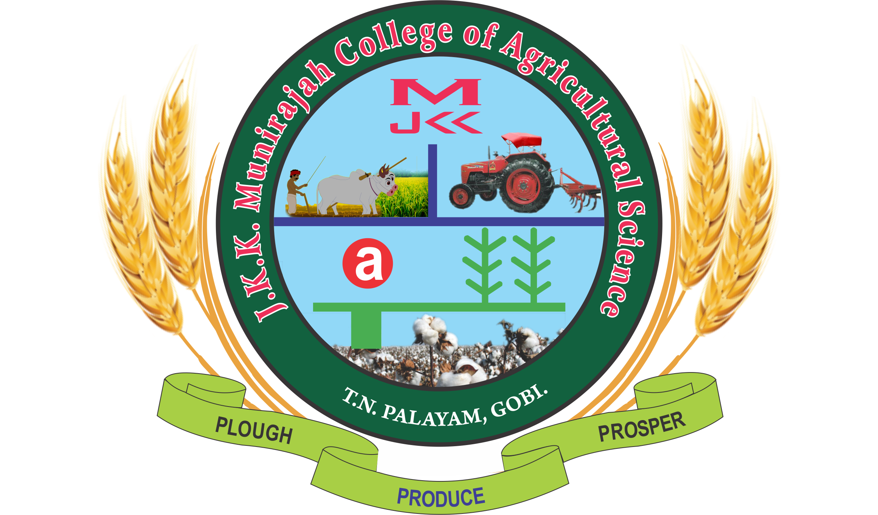

Invitation

OPEN DAY – 2019

05.04.2019 (Friday)

By
Management, Dean and Staff

 | J.K.K.MUNIRAJAH COLLEGE OF AGRICULTURAL SCIENCE  (Affiliated to Tamil Nadu Agricultural University)  T.N.Palayam – 638 506, Gobi (Tk), Erode (Dt) | 
OPEN DAY - 2019

AGENDA

Time : 10.30 a.m. Venue : Audio Visual Lab

Welcome Address : Dr.C.Senthilraja, Ph.D.,
Staff Advisor, JKKMCAS

Presidential Address : Dr.V.K.Duraisamy, Ph.D.,
Dean (i/c), JKKMCAS

Special Address : Dr.S.Rageshwari, Ph.D.,
Asst.Prof.(PAT)

Procedure to be adopted : Dr.A.Ravanachandar, Ph.D.,
For applying degree Asst.Prof(HOR)

About JKKMCAS, : Dr.S.Seethalakshmi,.Ph.D.,
T.N.Palayam Asst.Prof.(SST)

Interaction with the : Academic Rules – Dr.M.Srinivasan, A.P.(AGM)
Students and parents Infrastructural Facilities – Mr.V.Mohankumar, A.P.(AGR)
Laboratory Facilities – Dr.K.S.Usharani, A.P.(PBG)
Placement Profile - Ms.M.Vaidheki, A.P.(STA)
Hostel Amenities - Mr.K.Selvakumar,A.P.(AGR)

Vote of Thanks : Dr.M.Shanmugaprema, Ph.D.,
Asst.Prof. (AEN)

